CHG0068260 – ARTS Lower Env Test Results

Summary
All 4 smoke test cases passed in the lower environment on 10/13/2026, with no open defects.
Environment | Total cases | Passed | Failed | Open defects
Lower environment | 4 | 4 | 0 | 0

Results
# | What to test | Expected result | Actual result | P/F
TC-01 | User can log in to ARTS successfully | Home page loads; user's name, Home, Logout and Help show in header | Home page loaded with Welcome Message. Header shows logged-in user "bala, nadipena" with Home, Logout and Help. | PASS
TC-02 | Audit module opens | Audit menu loads; Create Audit form loads with dropdowns populated | Audit menu loaded with all 7 items. Create Audit form loaded; Unit (A01 – Office of the President) and Audit Group dropdowns populated. | PASS
TC-03 | Risk module opens | Risk menu loads with all 7 items | Risk page loaded with all 7 menu items. | PASS
TC-04 | Code Table Maintenance module opens | Code Table menu loads with all 8 items | Code Table Maintenance page loaded with all 8 menu items. | PASS

Evidence
TC-01 – ARTS home page after login
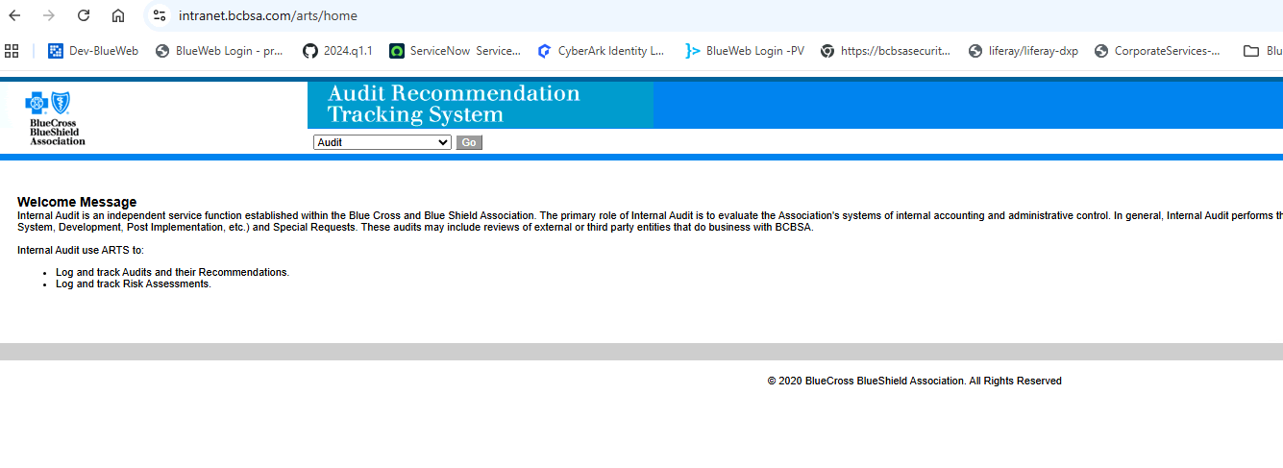
TC-02 – Audit module, Create Audit form (logged-in user shown in header)
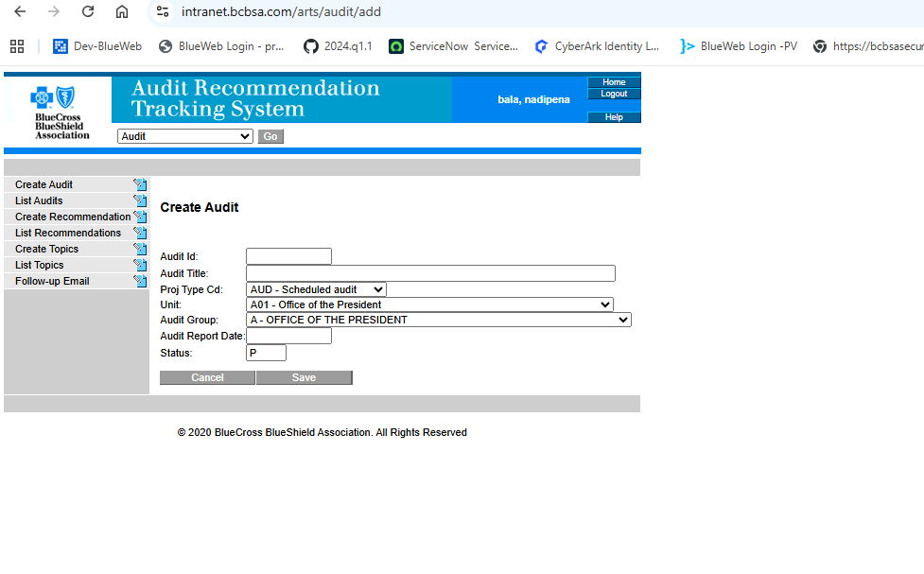
TC-03 – Risk module
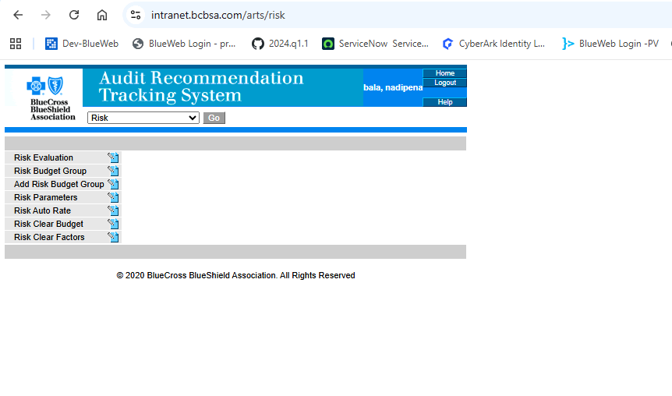
TC-04 – Code Table Maintenance module
